Developed by Netscape and released in 1995

|  |  |
| --- | --- |
| **JavaScript** | **Java** |
| Based on C Syntax | Based on C Syntax |
| Host-based scripting language | Stand-alone programming language |
| Readable source code | Bytecode compilation required |
| Runs as embedded code in HTML file or as a called javascript file | Runs from prompt or within Integrated Development Environment (IDE) such as NetBeans |
| JavaScript files stored with .js extension | Java files stored with .java and .class file extensions |

**ALLOW JAVASCRIPT IN FIREFOX**

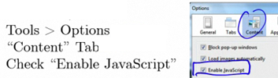

**ALLOW JAVASCRIPT IN IE**

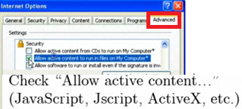

**ALLOW IN APPLE SAFARI**

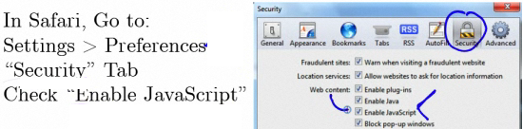

**ALLOW GOOGLE CHROME**

